**Section 1 – Getting Started**

Chapter 1 – What is Vue JS ?

1. A JavaScript framework that makes building interactive and reactive web frontends (= browser side web applications) easier.

* JavaScript is a programming language that is supported by all browsers. It allows you to manipulate the already running page and hence provide richer user experiences. It allows us to manipulate what the user sees on the screen without fetching a new page from the server and provide rich user experiences.
* Framework is a (third party) library that exposes utility functionalities AND a “set of rules” (a clear guidance) on how to build your JavaScript application, exposes certain utility functionalities, no need to write by your own.
* Reactive means your app is able to react to user input, update the screen dynamically (e.g. to show overlays or input validation errors) => Look and feel of mobile apps, should be very responsive to what the user does.
* Web frontends means “What the user sees” => HTML + CSS + JavaScript, running in the browser of your user.

1. Traditionally, in web apps, you click a link, and wait for a new page to load. You click a button and wait for some action to completely.

Client Side

Server Side

Request

HTTP Page [No Need]

* JavaScript runs in the browser on the loaded page
* You can manipulate the HTML structure (DOM)(Data of Model) of the page
* [No need] means No (visible) request to the server required, no need to wait for a new HTML page as a response.

1. You can build ANY kind of web application with just “vanilla” JavaScript, but “Just JavaScript” May Not Be Ideal! Why? No framework like Vue is needed! But

* You have to write all code on your own(“re-invent the wheel”)
* You might write suboptimal code or introduce errors and bugs
* Working in a team might be harder because not everyone knows your structure and “code philosophy”

Chapter 2 – Different Ways of Using Vue

1. Function of Vue

* To control parts of an HTML page or entire pages, make it more reactive and interactive. “Widget” approach on a multi-page-application. (Some) pages are still rendered on and served by a backend server.

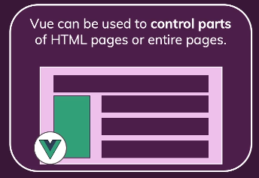

* To control the entire frontend of a web application. “Single Page Application” (SPA) approach. Server only sends one HTML page, thereafter, Vue takes over and controls the UI.

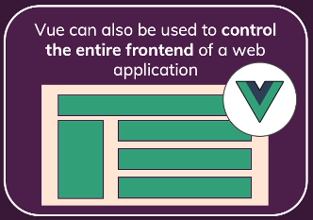

Chapter 3 – Vue Alternatives

1. Vue.js

Complete component-based UI framework includes most core features. A bit less popular than React and Angular.

1. React.js

It is basically also a JavaScript framework; it is just a library because it has less features than Vue actually. Focus on rendering UI and it misses some features like routing which Vue offers out of the box.

1. Angular

Another framework for JavaScript, has more features than Vue, so it helps you with even more problems